**Tracking Down Stu**

NOTE: Some Names, Location and Timings where changed to protect Stu and his Clients Operational Security.

So as many of you probably know The Many Hats Club “TMHC” do weekly podcasts on Tuesday was calling scammers and attempting to social engineering them. Sitting with my coke and prawn cocktail walkers I waited patiently for the time to roll and it did, but no podcast.

Reading the chat messages I came across the biggest mistake that Stu could make. “To note, we don’t stalk STU, but in cases such as this one, when asked he usually says ‘go on then’ so we do.

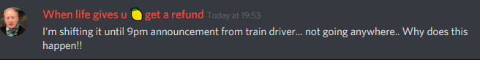

This message was Followed by



This was followed on voice chat by a user called Duniel “I wonder where he is”…. THE CHALLENGE, I had nothing else to do as I was saving my coke to sip during the calls. So I jumped on LinkedIn to Find Stu as I know I’ve seen him on there and Bammm got him



He’s in the UK, UB3R 1337 DOX… wait no we know he’s in the UK that’s no Duh, but where, maybe check his job listing.

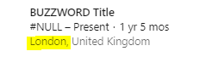

Easy, we know he works in the London, wait he said he was stuck on a train, in London on the way to a client that should be hard how many trains could there be in London. Lets dig into RailDar a website dedicated to tracking trains for times and delays in the UK.

Well…. Damn

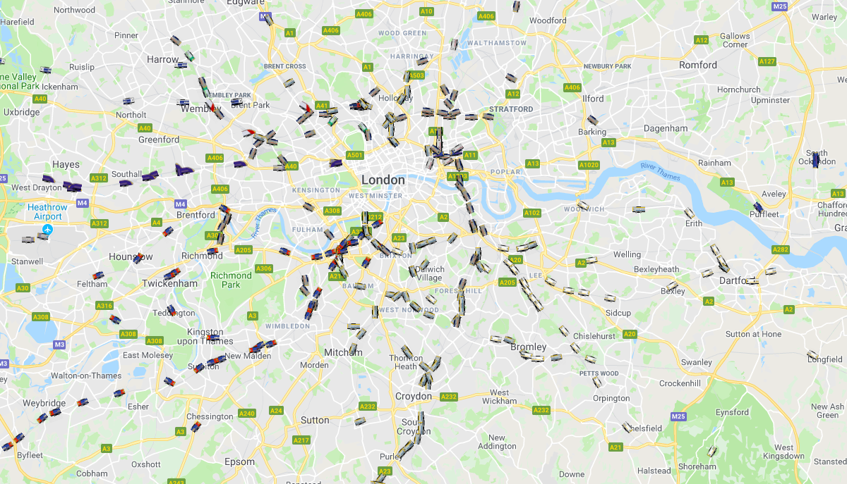

Ok lets rethink this one…  
  
lets look for delayed trains, Ohhh wait hey national rail thanks for doing that for me, just checking their online list of disruptions we find this little message



Hmmm not many trains on that route let’s get down to the map and find the location, oh look a train sitting between the two stations

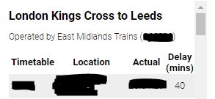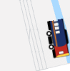

A poor lonely train sitting there, all alone on the track with Stu, I wonder what it looks like… and thanks to the many railway enthusiast we can as most tracks outside London have openly available cameras that can be easily found with Google dorks like this one,

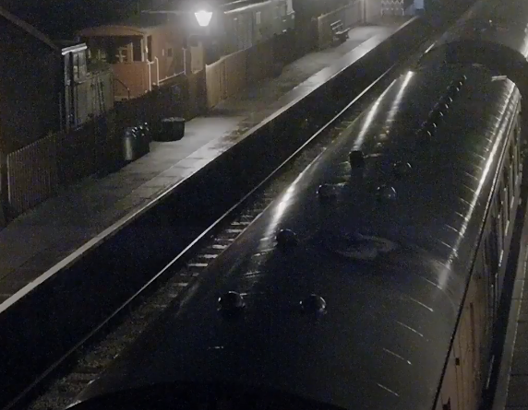

Oh hey look it’s a train, it doesn’t look to sad, it looks kind of ok, phase two try get a camera close to the leads train station to see if he leaves the station or if he just gets another train.

So we wait and we wait and we wait… and Wooo the train takes off, so now we monitoring for the train at the center, it arrives according the raildar, but yet the only people to really leave the station are a few small groups and a hen party. He might be going somewhere else, unless this camera had terrible marking telling me that the building on the lower right was the train station.

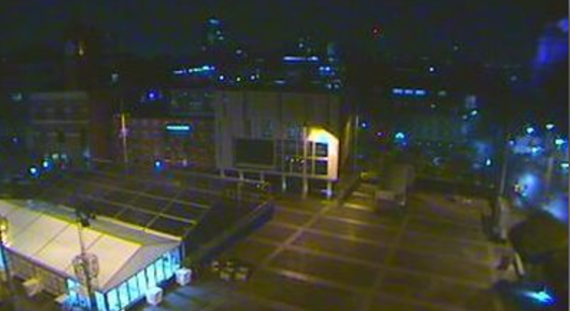

Lets check what trains are leaving around this time…

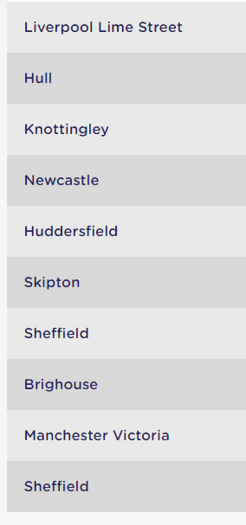

Well damn there goes that Idea there is a few leaving within the next hour.

So now we wait even longer, until Stu joins voice chat saying “im nearly at Rochdale, when I get to the hotel il start the calls then”   
HE GAVE US THE LOCATION.

Straight to Google, damn yes it’s the train to Manchester Victoria He would need to be on that one

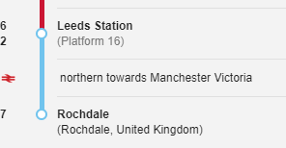

Damn found it straight away only one train on that route and it’s on time

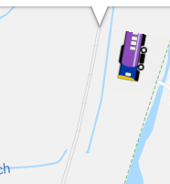

We need to see Stu on the ground, let’s try get a camera in Rochdale train station, but could only find one that was next to, and hopefully that was the street he walked down as he got off the train,

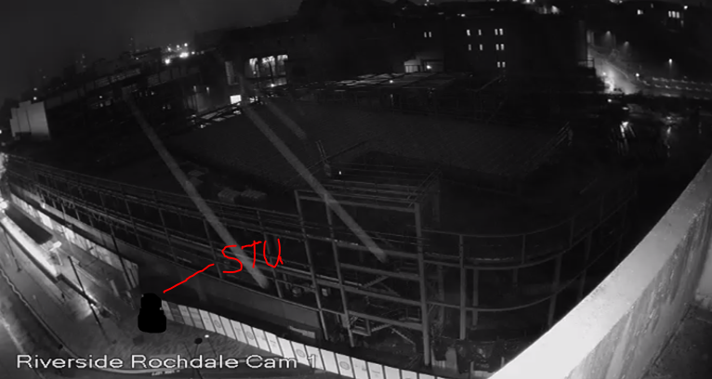

But unfortunately no dice, no sign of him other then for one brief couple of frames, unless he was disguised as a old lady and took an hour to walk from the train station, I didn’t find him on any other cameras around the location

After a little bit, Stu joined chat while checking into his hotel, after checking in said it had a great bar that he was going to meet someone in for food soon. Then after when finial in his hotel room “it’s cold out, lucky enough The hotel was close to the train station”

Looking at Google there are only 3 hotels that match the specifications given by Stu’s last message that includes Bar and close to train station,

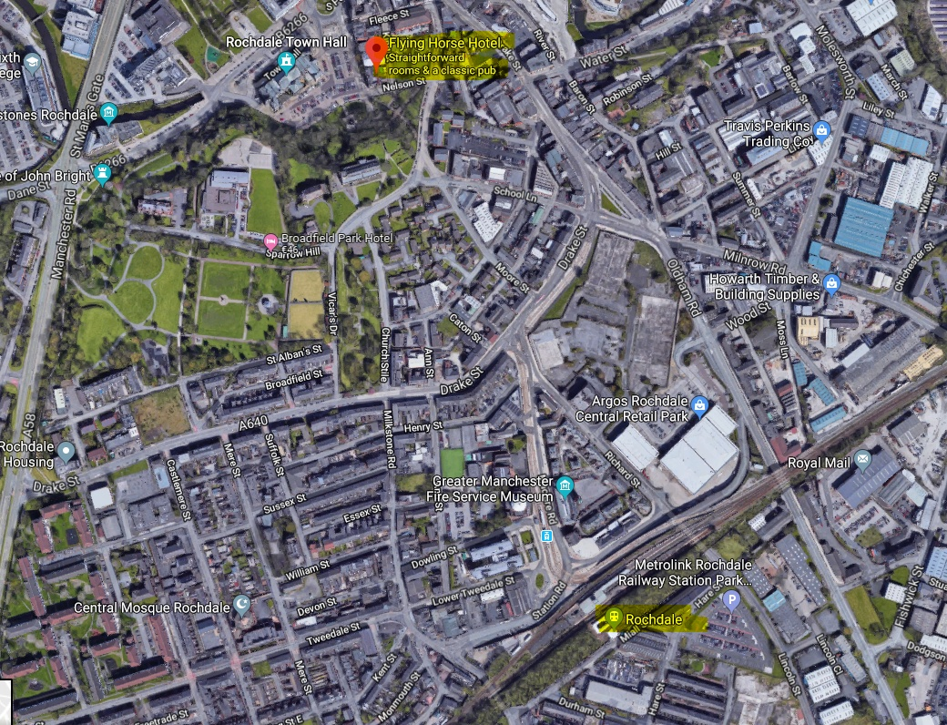

Lucky enough this is beside the Town hall, and a quick search finds a webcam from the townhall point right over the location with a perfect view of the front door according to Google maps

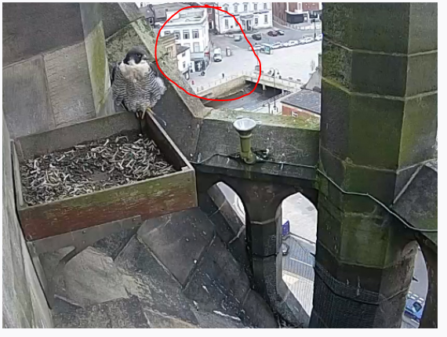

But it has been offline for maintenance over the needed time…



This is where this line ends unforuntantly, so close, but yet so far… mainly because I’m out of coke and prawn cocktail walkers lol